SSH to your AWS Workstation

**ssh devops@<public-ip-addr**> of your Workstation  
Password is : **Dev0p$!!/**

1. Check if Docker is installed and running.

|  |
| --- |
| $ sudo su (password is Dev0p$!!/ ) # docker version |

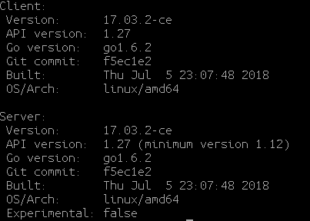

2. Create the first hello-world container.

|  |
| --- |
| **#** docker run hello-world |

*“Docker will search the local image repo and if the hello world image is not present it will then download it from the docker hub. ( docker hub is the default search engine where docker pulls new images from DockerHub default repository )”*



To download a particular image, or set of images (i.e., a repository), use **docker pull** as below.

3. The below command will always use the default tag as latest

|  |
| --- |
| # docker pull nginx |

4. Pull image based on tags

|  |
| --- |
| # docker pull nginx:stable |

5. The below command will use list all the docker images available on your local repository

|  |
| --- |
| $ docker images |

